Google Meet Quick Start
To help you get started with your Chromebook, here is a quick guide to getting on to Google Meet. Google Meet is how you will have “face to face” training sessions with your mentor. We will schedule a session for you and provide the date, time & meeting code (see the bottom of this document)
Preparation: Check these 3 things
- Make sure your Chromebook and Mifi are charged and turned on.
- Log on to the Chromebook using the password you received with the Chromebook.
- Check that the Mifi has linked to the Chromebook.


  - Move the mouse so that the arrow rests on the wireless symbol in the bottom right of the screen (to the left of the time).
  - It should say “Connected to Verizon Mifi, strong signal.”
  - If it says “weak signal” try moving the wifi to a different location.
  - If it says “not connected”, contact your local A4TD office.

Getting started with Google Meet:


- Start Google Chrome to get on to the internet. Do this by moving the mouse so the arrow is on top of the Chrome icon located at the bottom of the screen (see picture right) and click the left mouse button.
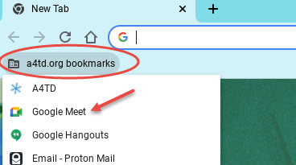
- In the upper left of the screen, you will find a link called A4TD.org bookmarks. Move your mouse so the arrow is over the word “bookmarks” and click the left mouse button. You will see a list show up.
- Move your mouse so the arrow is over “Google Meet” and click the left mouse button. Now you will see the Google Meet web page.
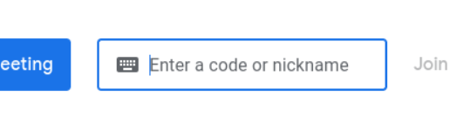
- Move the mouse arrow into the box that says “Enter a code or nickname” and click the left mouse button. Type in the meeting code then press the enter key on the keyboard. (Code for orientation sessions is listed at the bottom. During orientation we will give a code to use with your mentor)
- You should see yourself on the screen. When you are ready to join the meeting, move your mouse arrow to the blue “Join Now” button on the right side of the screen. Click the left mouse button to join the meeting.
If you were unable to join the meeting following the steps above, please make sure your Mifi unit is turned on then try again going through each step carefully. If you still can’t get into the meeting call the phone number provided and enter the PIN when prompted. This will get you into the meeting by phone and your mentor can talk you through the steps
If you are attending an orientation session, use the following code just for the one time orientation meeting to acquaint you with using Google Meet.
Google Meet Code: ypo-pktr-ysx OR
you may call: 727-330-1381‬ then enter the PIN: 433 549 332‬#‬‬
Record Information for meeting with your mentor here:
Date: ____________ Time: _______________ Meeting Code: ___________________
In case you have problems connecting to a meeting with you mentor, you can call in by phone __________________, then enter the PIN: _______________ number when prompted.

